# **FIND A JOB/WORKER IN TOTAL SECURITY**

## **Group Team:**

| Name |  | Campus ID | Email |
| --- | --- | --- | --- |
| AURORE FRITEAU |  | 032264451 | aurore.friteau01@student.csulb.edu |
| RICHARD PEREZ |  | 032038472 | richard.perez01@student.csulb.edu |
| THANH NGUYEN |  | 031661420 | thanh.nguyen05@student.csulb.edu |
| BRANDON CHAU |  | 028171804 | brandon.chau01@student.csulb.edu |
| BRYAN ESTRADA - CORDOBA |  | 028776031 | Bryan.Estrada-Cordoba01@student.csulb.edu |

## **Log of dates and changes:**

| 11.01.2023 | Created the introduction; Created the GitHub repository, |
| --- | --- |
| 11.02.2023 | Created the Introduction; Added the user stories; Created Use Case #1 |
| 11.03.2023 | Created Use Case #2 and #3 |
| 11.04.2023 | Revised Use Cases #1 - #3; Constructed the Product Backlog |
| 11.05.2023 | Created Sequence Diagram; Finalized document |

**INTRODUCTION**

In the modern digital age, a platform is needed to be the bridge between workers and employers. The platform has priority to help employers find workers more easily and workers find employers faster too. Indeed, this system is designed to serve several key purposes and offers an array of major features to facilitate seamless connections and service exchange between these two essential user groups. The primary purpose of this system is to connect workers and employers efficiently so the first major feature is the **Service Connection**, then **User profiles**. In fact, users can create their own profiles, highlighting their skills and experiences. Once the profiles are created a search engine allows employers to find the right workers and vice versa, based on location, availability, and skills. The employer has access to a list of where workers are localized according to their city. This third feature is **Search and Match.** If a worker pleases him, the employer can make a request. Afterward come the **Job Posting,** the job’s description will be added to the list accessible to the worker in chronological order. Workers can accept or reject requests. If accepted, they will automatically become unavailable for any other requests and receive the contact information of the employer. Once the worker accepts the job, the platform gives the worker and employer their respective contact. When the job is done, the platform has two purposes. Allowing **Secure Payment Processing** and **Ratings and Reviews** from the employer to the worker.

This system not only brings workers and employers together, but also improves the overall experience of finding services. Thanks to its many features, it meets the specific needs of both parties, making it a valuable tool in today's employment economy.

## **GLOSSARY:**

## **USERS STORIES:**

**Scenario 1:** As an employer, I can hire a local worker so that they can complete a job for me.

**Scenario 2:** As a worker, I can receive a job request so that I can work.

**Scenario 3:** As an employer, I can rate a worker so that my opinion about their performance is shared with other employers.

**Scenario 4:** As a worker, I can chat with an employer about the details of a job before accepting the job

**Scenario 5:** As a worker, I can securely receive my payment so that I get compensated for my work.  
**Scenario 6:** As a worker, I can rate and review an employer so that I can help influence the decisions of other workers in a supportive way.

**Scenario 7:** As a worker, I can start a project bidding so that workers in the app can bid on who will complete the request with low cost and good quality.

As a worker, I would like to make a function named Project Bidding. employers will post their project in the app and “worker” will bid on it to find who can do that project at a low cost and good quality.

**Scenario 8:** As an employer, I would like to be able to track the worker's progress so that I know how much work they've completed.

**Scenario 9:** As an employer, I can submit a service request on the app so that I can hire a worker with carpentry skills.

**Scenario 10:** As a worker, I can receive and respond to service requests from employers on the app so that I can provide carpentry services.

## **USE CASE:**

**Use case #1:** Rating the Worker at the end of the contract.

| **Sequence #** | **Actor’s Actions** | **System’s Actions** |
| --- | --- | --- |
| 1 | Worker completes the job request and updates their progress in the app |  |
| 2 |  | Our app notifies the employer that the worker completed the job request |
| 3 | Employer verifies that the job is complete and confirms in the app |  |
| 4 |  | Our app sends an optional review to the employer to rate the worker |
| 5 | The employer completes the review and publishes it. |  |
| 6 |  | Our app stores the review in the database associated with this specific worker |

Alternate Course of Action

| **Sequence #** | **Actor’s Actions** | **System’s response** |
| --- | --- | --- |
| 1 | Employer writes a review for the worker |  |
| 2 | Employer decides to revise the review before submitting the review |  |
| 3 | Employer submits the review |  |
| 4 |  | Our app stores the review in the database associated with this specific worker |

Exception Course of Action

| **Sequence #** | **Actor’s action** | **System’s response** |
| --- | --- | --- |
| 1 |  | Our app stores the review in the database associated with this specific worker |
| 2 | The worker receives a notification saying he has been rated.  He disagrees with the grade so contact the support by giving details. |  |
| 3 |  | Email send to assistant’s support who will contact the employer and figure out what appended |
| 4 | Two options:  -assistant support deleted the grade  -the worker is warned to be exclude, if his behavior was the reason of having a bad grade |  |
| 5 |  | system ask for the evident to prove the worker review is not true |
| 6 | if the worker can show the evident |  |
| 7 |  | the system will remove that review |

**Use Case #2: An Employer Puts Out a Request for a Job**

*Main Flow*

| **Sequence #** | **Actor’s Actions** | **System’s response** |
| --- | --- | --- |
| 1 | An employer puts out a request for a job in the app |  |
| 2 |  | Our app displays the potential job offer to qualified workers in the local area |
| 3 |  | Our app notifies the employer that there are workers interested in completing the job |

*Alternative Flow*

| **Sequence #** | **Actor’s Actions** | **System’s Actions** |
| --- | --- | --- |
| 1 | An employer puts out a request for a job in the app |  |
| 2 |  | Our app displays the potential job offer to qualified workers in the area |
| 3 |  | Our app doesn’t find qualified workers in the area and in response expands the search radius to find qualified workers |
| 4 |  | Our app notifies the employer that there are workers interested in completing the job |

*Exception Flow*

| **Sequence #** | **Actor’s Actions** | **System’s Actions** |
| --- | --- | --- |
| 1 | An employer puts out a request for a job in the app |  |
| 2 |  | Our app displays the potential job offer to qualified workers in the area |
| 3 |  | Our app notifies the employer that there are workers interested in completing the job |
| 4 | An employer decides to cancel the job request |  |
| 5 |  | Our app removes the job request from the database |

**Use Case #3: A worker is hired for to provide a service**

*Main Flow*

| **Sequence #3** | **Actor’s Actions** | **System’s Actions** |
| --- | --- | --- |
| 1 |  | Our app displays potential job offers in the area |
| 2 | A worker chooses a job request from the requests that best match their skill set |  |
| 3 |  | Our app notifies the employer that there is a worker interested in completing the job request |
| 4 |  | Our app notifies the worker that they have been hired to complete the job request |

*Alternative Flow*

| ***Sequence #*** | ***Actor’s Actions*** | ***System’s Actions*** |
| --- | --- | --- |
| *1* |  | Our app displays potential job offers in the area |
| *2* | A worker chooses a job request from the requests that best match their skill set |  |
| *3* |  | Our app notifies the employer that there is a worker interested in completing the job request |
| *4* |  | Our app notifies the worker that the job request has been given to another worker |
| 5 |  | Our app displays other potential job offers in the area |
| 6 | A worker chooses a job request from the requests that best match their skill set |  |
| 7 |  | Our app notifies the employer that there is a worker interested in completing the job request |
| 8 |  | Our app notifies the worker that they have been hired to complete the job request |

*Exception Flow*

| **Sequence #** | **Actor’s Actions** | **System’s Actions** |
| --- | --- | --- |
| 1 |  | Our app displays potential job offers in the area |
| 2 | A worker chooses a job request from the requests that best match their skill set |  |
| 3 |  | Our app notifies the worker that the job request has been canceled by the employer |

**Sequence Diagram:**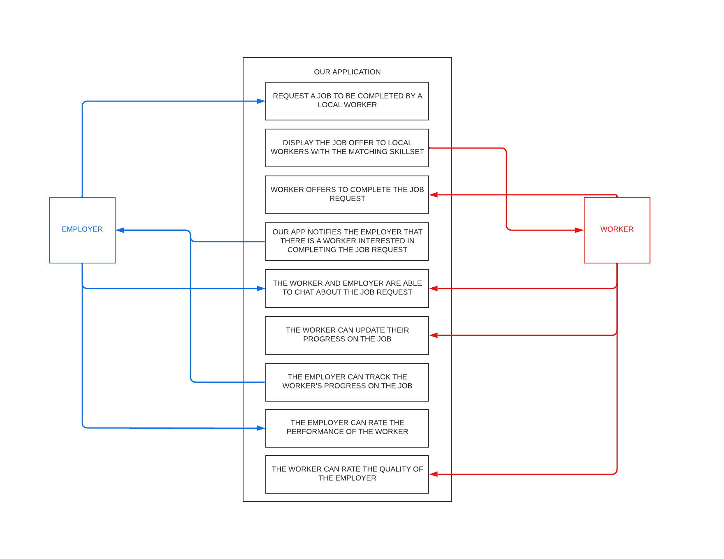

**PRODUCT BACKLOG:**

**Local Service Market on app**

| **ID** | **Description #Sprint**  **Effort needed for Release 1 as in the beginning of the Sprint** | 1  104 | 2  48 | 3  22 | 4  0 | 5  0 |
| --- | --- | --- | --- | --- | --- | --- |
| 1 | Set up continuous integration system | 10 | 0 | 0 | 0 | 0 |
| 2 | Create compilable application skeleton | 10 | 0 | 0 | 0 | 0 |
| 3 | Create workers can store their skills | 8 | 0 | 0 | 0 | 0 |
| 4 | Create employers | 8 | 0 | 0 | 0 | 0 |
| 5 | Make an UI can show all the workers | 20 | 0 | 0 | 0 | 0 |
| Sprint 1 | Make a run to try the UI and database work well |  |  |  |  |  |
| 6 | Make payment system | 10 | 10 | 0 | 0 | 0 |
| 7 | add image to workers and employers profile | 3 | 3 | 0 | 0 | 0 |
| 8 | make when worker accepted the employer request  they will both be in contact. The worker can’t accept another request until this is done. | 3 | 3 | 0 | 0 | 0 |
| 9 | Make an online chat for worker and employer | 5 | 5 | 0 | 0 | 0 |
| 10 | Make a rating system | 5 | 5 | 0 | 0 | 0 |
| Sprint 2 | Minimal working version |  |  |  |  |  |
| 11 | implement support for location | 10 | 10 | 10 | 0 | 0 |
| 12 | securely receive funds | 7 | 7 | 7 | 0 | 0 |
| 13 | post review in worker profile | 5 | 5 | 5 | 0 | 0 |
| Sprint 3 | Run the app in the real situation |  |  |  |  |  |
| Release 1 | Sellable version |  |  |  |  |  |
| 14 | Project bidding | 10 | 10 | 10 | 10 | 10 |
| 15 | Track the worker’s progress | 7 | 7 | 7 | 7 | 7 |
| 16 | Plug real ads in | 40 | 40 | 40 | 40 | 40 |
| Sprint 4 | Advertisements support and new functions |  |  |  |  |  |
| Release2 | Ad-supported and implemented new functions |  |  |  |  |  |
|  | **Effort in the whole backlog** | 161 | 105 | 79 | 40 | 40 |

